Web Space for Students Using FileZilla
To setup a new connection, click File and select Site Manager from the menu.
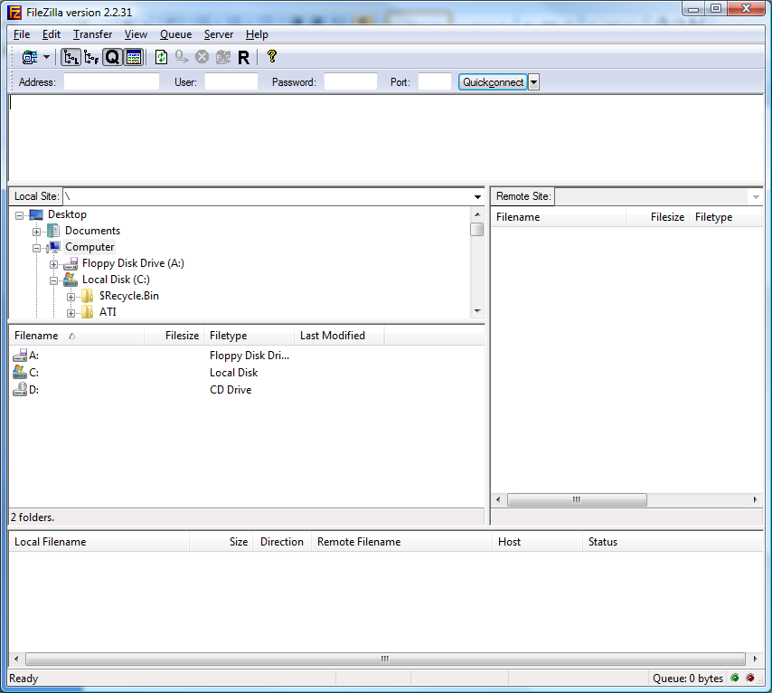

Select New Site at the bottom of this screen.
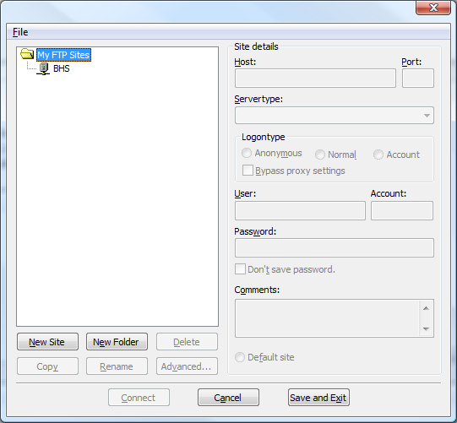

Type Nipissing Webspace as the new connection name. Fill the fields as you see on the image below.
Host: home.nipissingu.ca
Port: 21
Servertype: FTP
Logontype: Normal
User: Your Username
Password: Your Webadvisor Password

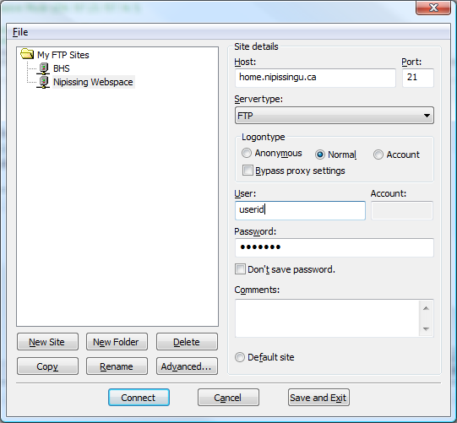

Click on the Advanced options button
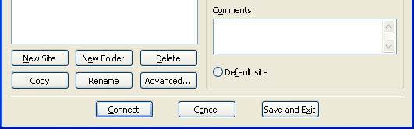

Enter /html in the Default remote Directory field. Then click OK.
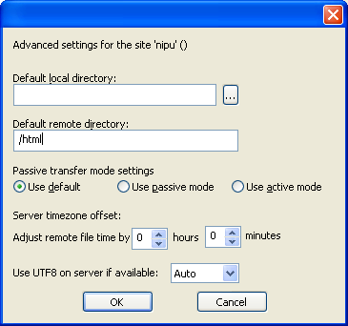

Click Connect when you have filled in the required fields.

Once connected you will see a screen similar to this one.
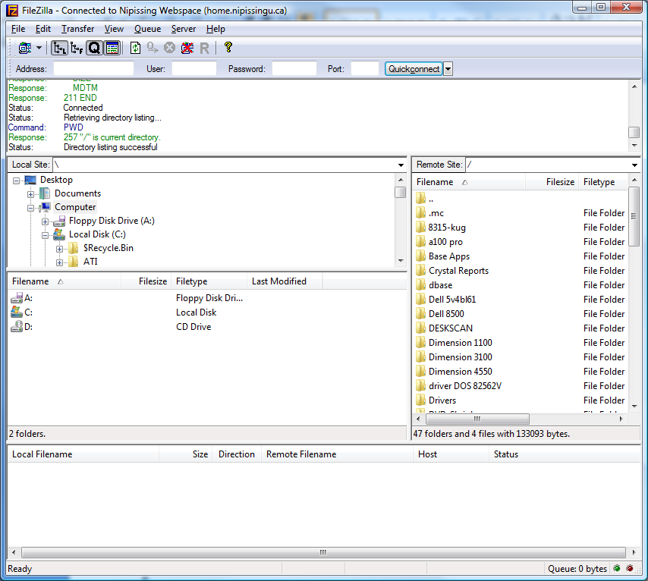
We’ve created an html subdirectory in each user’s home directory. Placing files inside this directory will make them browsable from the web. The URL for each user’s web space is in the form of home.nipissingu.ca/<userid>. Placing a file called “index.html”, “index.htm”, “defaut.htm” or “default.html” in the html subdirectory will cause that file to be the default page.
To browse your webpage type: http//home.nipissingu.ca/<userid> in your browser

