Memory Aid Student Checklist and Examples
- Discussion with Faculty. Student speaks with instructor early in the semester about the memory aid accommodation and the allowable content based on each course’s learning outcomes.

- Creation of Memory Aid. The student identifies and summarizes material throughout the course for possible use on the memory aid sheet. If the student requires support in developing cueing summary skills, they will contact their Accessibility Consultant.

- Approval of Memory Aid at least 5 business days before the test/exam. Students must email their proposed Memory Aid sheet to the instructor and copy their Accessibility Consultant on the email within a minimum of 5 business days before a test. Should revisions be required, the student will make the changes and resubmit for approval by the instructor within 3 business days of the test.

- Professor submits the Memory Aid. Professor will include the final approved Memory Aid sheet with the test. The memory sheet is collected with the completed test.

Memory Aid Examples: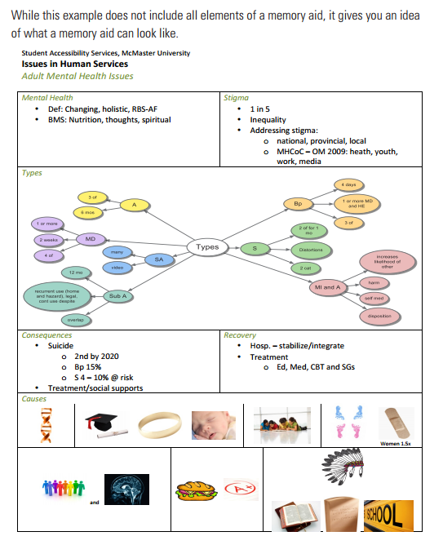
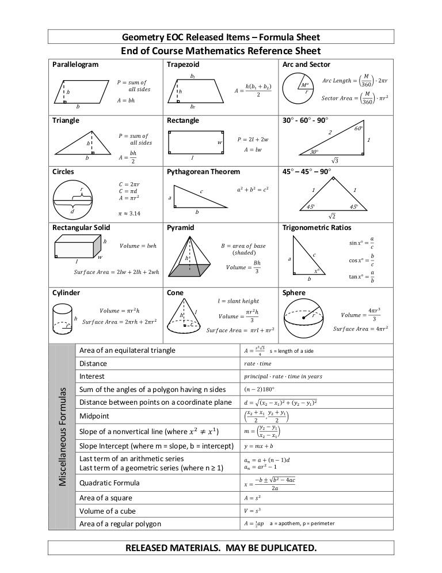

Sources: https://www.slideshare.net/adheeradra/geometry-formulasheet
http://sas.mcmaster.ca/wp-content/uploads/2014/12/memory-aid-2014.pdf

