How to enroll in SAS-ATP Student Accessibility Services Blackboard Course Shell

1. Login to Blackboard
2. Click the following link:

<https://learn.nipissingu.ca/webapps/blackboard/content/listContentEditable.jsp?content_id=_521431_1&course_id=_16951_1&mode=reset>

1. Click the ‘Enroll’ button on the left menu:

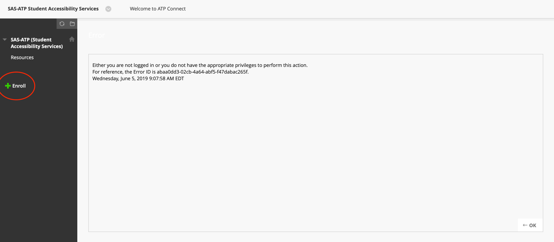

That’s it!

Now, when logging into Blackboard, you will see this course show up on your main landing page for easy access!